horizontal line

Board Meeting

Date: Upcoming, to be determined (Before 3/10/2017)

# Agenda

## Last Meeting Follow-up

1. See last meeting’s agenda:  
   <https://docs.google.com/a/ucsd.edu/document/d/1-LsD_jAkjVi8V94gnQ4ekwJg2hdIhGCFjGMm_o50u2Q/edit?usp=sharing>
2. Review officer positions:  
   <https://drive.google.com/open?id=0B-o5ELumsfcpdnJrV1pMRFJNNFU>
3. Review previous minutes:  
   <https://docs.google.com/document/d/1dydFp2nwOSsA8N9npB-6yM1Yi0sDZ-zhL6rlgFj3EdQ/edit#heading=h.wcmv4moko1we>

## New Business

1. GBM Updates
   1. What is the status of the room?
      1. Bueno with 2 rooms
   2. What is the status of the funding request?
      1. Final review
   3. Review: what do we want to accomplish with this GBM, and how are we going to do it?
      1. Decide on 2-3 major talking points
         1. Future events
         2. What we do
   4. Confirm timing, if not exact location
      1. Have two rooms booked - a small one in AP&M, and a bigger one anywhere else
         1. Note: APM b402A holds 70 people.
         2. PC holds 80
      2. This way we can get a head count, then have another option if turnout looks like it will be high
   5. Logistics - roles should be assigned now
      1. Outreach - Should start ASAP
         1. RSVP form - needed for headcount.
         2. Web page - to link on flyers, convey more info
         3. Facebook event - might as well put it up now, should have links to RSVP and web page + clear description of **why** someone should attend
         4. Flyers - bigger job than usual, cover more parts of campus.
            1. Strategy: Design flyers ASAP. Be sure to add bleeding and crop marks. Give to Imprints and let them cut (takes 1-2 days).
            2. Buy good tape, especially if they’re outside - otherwise they’re trashed in a matter of days by wind/rain/etc
            3. Plaster the entire campus honestly. (But obscure places are a waste of time/effort!! High traffic + high visibility only in order to maximize your efficiency)
      2. Refreshments
         1. Probably need at least 3 people involved
            1. Not just for planning, but also for going out and actually *getting* the food on the day!!
         2. Determine basic food/drinks ASAP, guess at attendance, and be prepared to scale up/down accordingly
         3. Use latex workshop numbers as a model
         4. **There are a lot of fiddly details to worry about here!**
            1. Utensils, plates, cups
            2. Tablecloths
            3. Set up and clean up
            4. What kind of furniture is available (tables? carts?)
            5. Asked for about $13 in funding.

Since, I was thinking of ordering pizza, I think plates, cups, and napkins are all we need. For clean up, we probably don’t need to worry as long as people didn’t puke.

1. Latex Workshop Post-mortem
   1. What worked? What didn’t?
   2. PMs hardly involved - do they want to be involved going forward? Do they have the time?
2. Passing off documents
   1. We need a quick an easy place to do things like leave flyers
   2. PMs: See if we can get a mailbox or office space.
   3. Solutions
      1. we can always leave things at AP&M front desk
      2. To each print themselves and show evidence of purchase to me (Aiden) and get money back from funding.
      3. Get a locker at pc
3. Website
   1. New website is up at [sums.ucsd.edu](http://sums.ucsd.edu)
   2. What do we do with [math.ucsd.edu/~sums](https://www.math.ucsd.edu/~sums/)
   3. Issue: old SUMS page has a **lot** of SEO traction, plus a sitemap(?) that makes 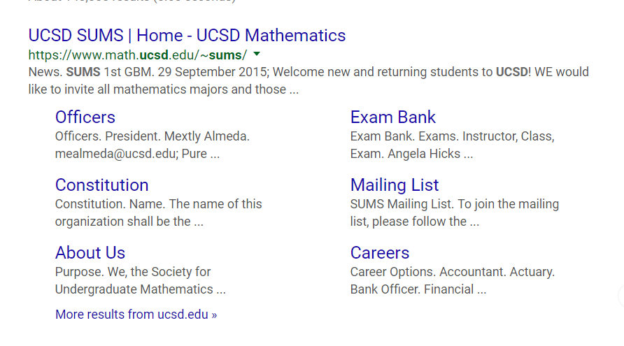the google result nicely formed:
      1. We don’t want to throw away our ranking, what can we do
         1. We can create a link from that page to ours. Or the other way. Whichever is the easier website to control.
   4. Content:
      1. We definitely need more, but the old content was **really** lame.
      2. Ideas?
         1. Contact us
         2. Brief intro (what we do)
         3. Event page
            1. Google calendar
         4. Why math major (career choices)
   5. Anyone who plans on ever doing edits needs to get on the Github org. Send Me (Zack) or Peter your github username to be added
      1. Plus, you’ll have to spend a few minutes with one of us to go over how content is edited, events are added, etc
4. Plan Elections
   1. Need to review this, we covered a bit at the last meeting.
   2. What positions should be made available? What is their purpose?
   3. What are the terms? Responsibilities?
   4. What is our recourse for officers who don’t work out?
   5. We need a plan completely nailed down before the GBM. If we’re confused, it’ll be confusing to everyone else.
5. Events
   1. Latex Workshop Post-mortem
      1. What worked? What didn’t?
      2. PMs hardly involved - do they want to be involved going forward? Do they have the time?
   2. March Events
      1. Nothing but lightning talks scheduled, no time for funding. Can we do anything else?
         1. (Note: short month, basically only three weeks of classes)
         2. Idea: visiting finals, provide snacks on the way out.
      2. Pi Day: No funding, but it wouldn’t be hard to do something anyway
         1. Would require pooling some money
         2. Also a good opportunity for **the student body to meet the club organizers.** I.e. it’s a huge waste if the major positions and PMs don’t make it to this event
         3. Things that would be cool to do:
            1. Book a room for an hour in the middle of the day, serve various types of pie (obviously)
            2. Have several large posters or triptychs made displaying facts about Pi (think of posters at undergrad research conferences)
            3. What else? It should be more than a meet-and-greet
         4. I (Zack) am willing to help with this a lot, but this is also a good opportunity for *other* people to take ownership of an event
   3. April Events
      1. Review what people requested!
      2. GBM scheduled, but this should be its own item
      3. Lightning talks: regular, already scheduled
      4. Will be booking every Friday 5-6pm slot for impromptu or small events
      5. Other events: we should do **way** more if we want people involved next year!
         1. Movie night (tentatively planned)
            1. Timing? Snacks? What movie? How to promote?

Potential room options:

pc theatre room

Potential Snack options:

Classic theatre food (popcorn, candy, ect...)

Catering food

* + - 1. Workshops: Ideas
         1. Another “Latex for Beginners”
         2. Intermediate Latex workshop
         3. Some kind of coding

R, numpy, octave, opengl

* + - * 1. 3D printing (esp. Parametric surfaces)
        2. Other ideas? Do members have workshops they want to do? Can we reach out to other organizations or faculty?
        3. Career workshop

Talking to professionals (professors, analysts, data scientists, school teachers, engineers)

* + - 1. Integration Bee
         1. **Requires a LOT of hard work**

Not just planning, but generating **good** content for this event requires being very thoughtful (anyone who’s taken Calculus should have a fighting chance!)

* + - * 1. Needs a bigger room than usual
        2. Huge audience - calculus spills over into Physics, CS, Econ, Biology, etc. Needs way more outreach than usual.
        3. We need judges, a timing mechanism, some kind of bracketing for matchups, etc
        4. Hold back for next year?
      1. Socials
         1. Professional stuff is good but SUMS is also a hangout place for Math majors. Having something to gather people and hang out will be great. Especially since we need to gather more people in preparation of a new school year.
         2. Ideas

Movie night as above

Potluck

Gaming night

Career talks/cafe night

Eating off-campus

1. Funding Requests
   1. Ones that definitely need to go ASAP:
      1. Math Movie Night: 1 week until deadline
      2. May events: 2-4 weeks, depending
      3. Spring Lightning Talks: 4 weeks
      4. April Events: 4-5 weeks, depending
      5. Integration Bee: 5 weeks

# Notes

# Action Items

1. Finalize *at least* March and April events
2. Set up standing room reservation: Fridays, 5-6pm, AP&M 7421 for Spring quarter
3. Have concrete logistic roles for GBM assigned (promotion team, food team, speakers, etc)
4. Determine 2-3 simple, concrete, high-level messages we want to convey at the GBM
5. Make sure every member has deadline calendar, delegate work for constructing and submitting funding requests

# Next Meeting Agenda Items

1. Finalize May and June events
2. Start forming 2017-2018 event calendar

* Things to prioritize for meeting on February 24th (in AJ’s opinion)
  + Finalize events that will be happening in Week 1 to Week 5 of Spring
  + Latex workshop review
  + GBM updates (publicity, content)
  + Planning elections
  + Funding requests for the finalized events
  + Discussion about events in March (I think we should focus on GBM solely, but I’m willing to put in effort if rest of board wants events the remainder of this quarter)

